**Write HTML code to create a following design:**

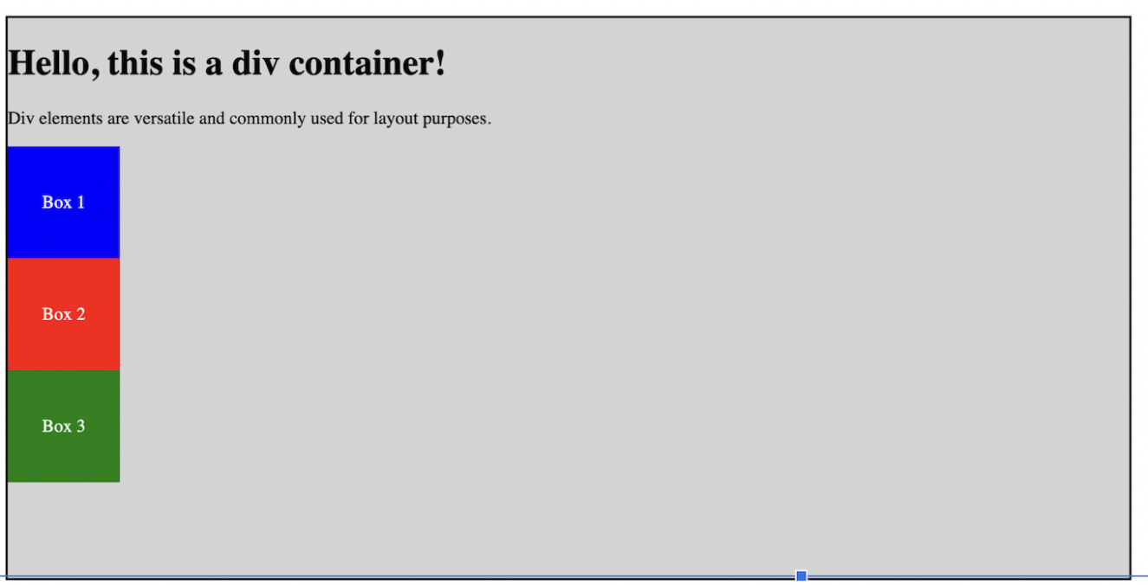

<html>

<head>

    <title>lab </title>

</head>

<body>

    <div style="border:2px solid black;">

        <h1> Hello, this a diver container!</h1>

        <div style="height: 100px;width: 100px; border:2px solid black; color:blue; background-color:yellow;" > Box1</div>

        <div style="height: 100px;width: 100px; border:2px solid black; color:black; background:blue;">Box2</div>

        <div style="height: 100px;width: 100px; border:2px solid black; color:white; background:red;">Box3</div>

    </div>

</body>

</html>

**Write html code to create a grid of images.**

<html>

<head>

    <title> lab </title>

</head>

<body>

    <div style="border:2px solid black;">

        <div>

          <h2>Photo Gallery</h2>

          <div>

            <div style="display: flex;margin: 10px 100px;">

                          <img style="margin:10px; height: 300px; width:300px;" src="1.jpg" alt="">

                          <img style="margin:10px; height: 300px; width:300px;" src="2.jpg" alt="">

                          <img style="margin:10px; height: 300px; width:300px;" src="3.jpg" alt="">

            </div>

            <div style="display: flex;margin: 10px 100px;">

                          <img style="margin:10px; height: 300px; width:300px;" src="4.jpg" alt="">

                          <img style="margin:10px; height: 300px; width:300px;"  src="5.jpg" alt="">

                          <img style="margin:10px; height: 300px; width:300px;"  src="6.jpg" alt="">

             </div>

             <div style="display: flex;margin: 10px 100px;">

                          <img style="margin:10px; height: 300px; width:300px;"  src="7.jpg " alt="">

                          <img style="margin:10px; height: 300px; width:300px;"  src="8.jpg" alt="">

                          <img style="margin:10px; height: 300px; width:300px;"  src="9.jpg" alt="">

             </div> </div></body></html>

Output:

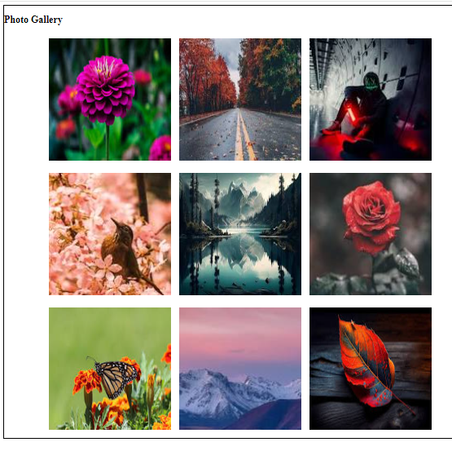

**Write HTML code to generate the following list of items.**

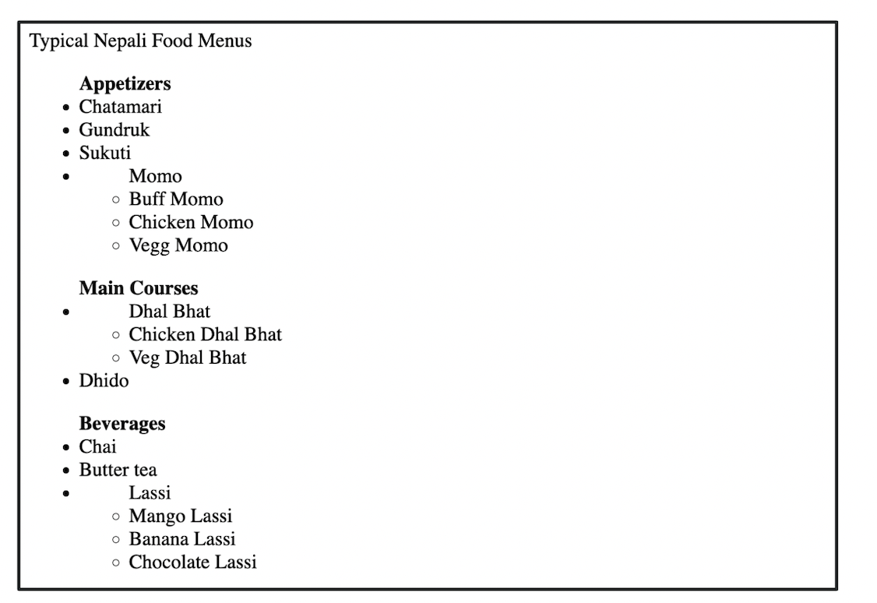

<html>

<head>

    <title>lab</title>

</head>

<body>

    <div style="border:2px solid black; margin:10px 20px 20px 15px; padding:10px 15px 20px 10px;">

        Typical Nepali Food Menus

        <ul>

            <b>Apetizers</b>

            <li> Chatamari </li>

            <li> Gundruk </li>

            <li> Sukuti </li>

            <li> Momo

                <ul>

                    <li>Buff momo</li>

                    <li>Chicken momo</li>

                    <li>Vegg momo</li>

                </ul>

            </li>

        </ul>

        <uL>

            <b>Main course</b>

            <li> Dal Bhat </li>

            <ul>

                <li> Chicken Dhal Bhat </li>

                <li> Vegg Dhal Bhat </li>

            </ul>

        <li>Dhido</li>

        </uL>

        <uL>

            <b>Beverages</b>

            <li> Chai </li>

            <li> Butter tea </li>

            <li> Lassi </li>

            <ul>

                <li> Mango Lassi </li>

                <li> Banana Lassi </li>

                <li> Chocolate Lassi </li>

            </ul>

        </uL>

    </div>

</body>

</html>

**Write html code to create the following table.**

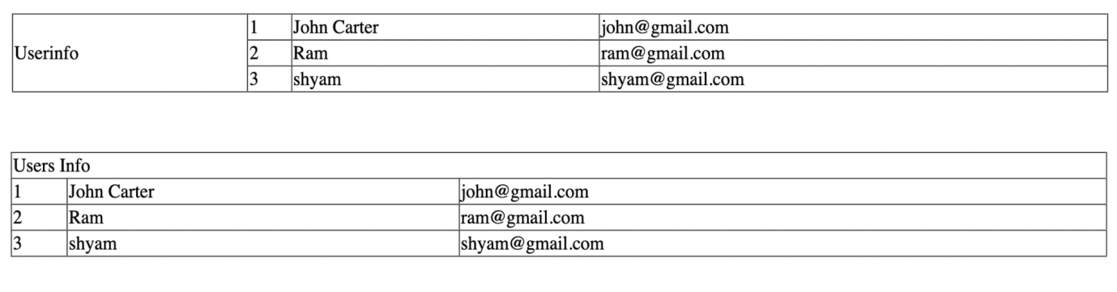

<html>

<head>

    <title>lab</title>

</head>

<body>

    <br><br>

    <table border="1px" style="border-collapse: collapse; width: 60%; margin-left:225px">

        <tr>

            <td rowspan="3">Userinfo</td>

            <td>1</td>

            <td>John Carter</td>

            <td>john@gmail</td>

        </tr>

        <tr>

            <td>2</td>

            <td>Ram</td>

            <td>ram@gmail.com</td>

        </tr>

        <tr>

            <td>3</td>

            <td>Shyam</td>

            <td>shyam@gmail.com</td>

        </tr>

    </table>

    <br><br>

    <table border="1px" style="border-collapse: collapse; width: 60%; margin-left:225px">

        <tr>

            <td colspan="3">Userinfo</td>

        </tr>

        <tr>

            <td>1</td>

            <td>John Carter</td>

            <td>john@gmail</td>

        </tr>

        <tr>

            <td>1</td>

            <td>Ram</td>

            <td>ram@gmail.com</td>

        </tr>

        <tr>

            <td>1</td>

            <td>Shyam</td>

            <td>shyam@gmail.com</td>

        </tr>

    </table>

    <br><br>

</body>

</html>

**Write html code to embed google map in your html page.**

<!DOCTYPE html>

<html lang="en">

<head>

    <meta charset="UTF-8">

    <meta http-equiv="X-UA-Compatible" content="IE=edge">

    <meta name="viewport" content="width=device-width, initial-scale=1.0">

    <title>google map</title>

</head>

<body>

   <br><br>

        <!--Google Map-->

        <iframe src="https://www.google.com/maps/embed?pb=!1m18!1m12!1m3!1d28277.689627423977!2d85.50365180855805!3d27.63345964907355!2m3!1f0!2f0!3f0!3m2!1i1024!2i768!4f13.1!3m3!1m2!1s0x39eb0f33b1a23b53%3A0xe8ec0b92bdf38a54!2sBanepa!5e0!3m2!1sen!2snp!4v1706372338448!5m2!1sen!2snp" width="600" height="450" style="border:0;" allowfullscreen="" loading="lazy" referrerpolicy="no-referrer-when-downgrade"></iframe></html>

Output:

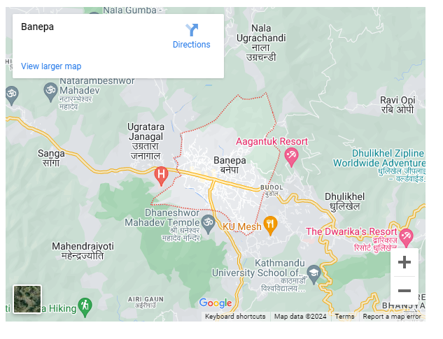

**Write html code to create the following form.**

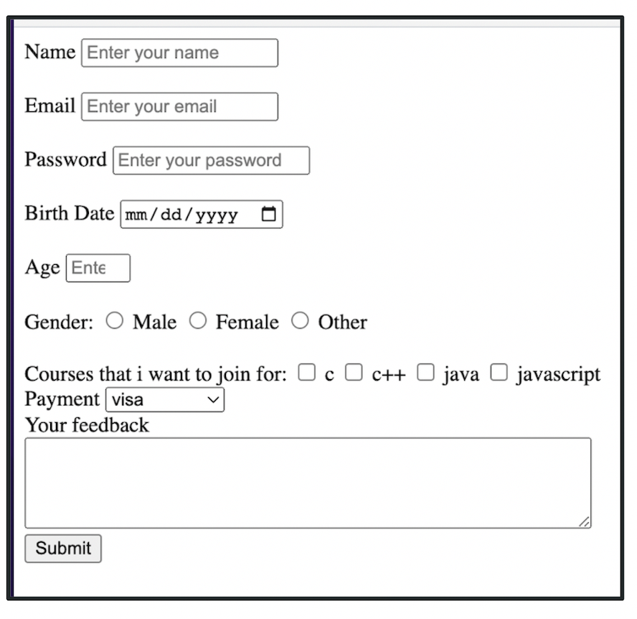

<!DOCTYPE html>

<html lang="en">

<head>

    <meta charset="UTF-8">

    <meta http-equiv="X-UA-Compatible" content="IE=edge">

    <meta name="viewport" content="width=device-width, initial-scale=1.0">

    <title>Form</title>

</head>

<body>

    <br><br>

    <form style="border: 2px solid black; width:fit-content;padding:20px;" >

        <label for="name">Name</label>

        <input placeholder="Enter your name" type="text" id="name" name="name" ><br><br>

        <label for="email">Email</label>

        <input placeholder="Enter your email" type="email" id="email" name="email"><br><br>

        <label for="password">Password</label>

        <input placeholder="Enter your password" type="password" id="password" name="password"><br><br>

        <label for="dob">Birth Date</label>

        <input type="date" id="dob" name="dob"><br><br>

        <label for="age">Age</label>

        <input placeholder="Enter your age" type="number" id="age" name="age"><br><br>

        <label>Gender:</label>

        <input type="radio" id="male" name="gender">

        <label for="male">male</label>

        <input type="radio" id="female" name="gender">

        <label for="female">female</label>

        <input type="radio" id="other" name="gender">

        <label for="other">other</label><br><br>

        <label>Courses that i want to join for: </label>

        <input type="checkbox" id="c" name="c">

        <label for="c">C</label>

        <input type="checkbox" id="c++" name="c++">

        <label for="c++">C++</label>

        <input type="checkbox" id="java" name="java">

        <label for="java">java</label>

        <input type="checkbox" id="javascript" name="javascript">

        <label for="javascript">javascript</label><br><br>

        <label for="payment">Payment</label>

        <select name="payment" id="payment">

            <option value="visa">visa</option>

            <option value="credit card">credit card</option>

            <option value="atm">atm</option>

        </select><br><br>

        <label for="feedback">Your feedback</label><br><br>

        <textarea name="feedback" id="feedback"></textarea><br>

        <input type="submit" name="submit" value="submit">

    </form>

</body>

</html>